Coaching Experience
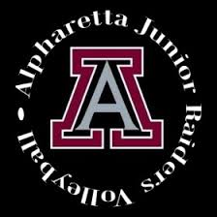

Amanda Garman
  - Head Coach – SIlver Team

Contact
ahsjrvolleyball@gmail.com

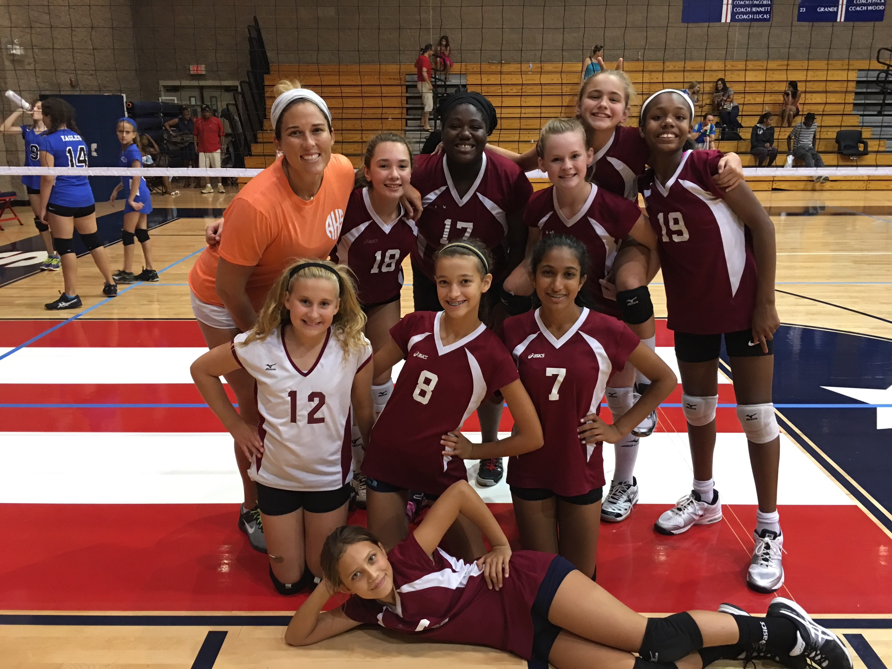

Alpharetta Junior Raider Coach
- August 2013-Present

ABOUT ME
I played volleyball at Milton High School from 2000-2004. On the off-season, I played for North Atlanta Volleyball Club. I then continued to play on the National Club Team from 2004-2008 at Appalachian State University in Boone, North Carolina. I was a middle blocker my entire volleyball career.
When not coaching – I work full time in the Risk Management field for the largest distributor of Drywall in North America at their corporate headquarters here in Atlanta, Ga. I CrossFit 5-6 days a week, play in an adult Softball league and ALTA Tennis. I have an adorable White Golden pup named George and an orange kitty named Marley and currently live in Midtown by Piedmont Park.

