Coaching Experience
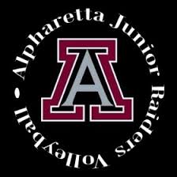

AShley Holly
  - Junior raider program
Head Coach – Silver team

Contact
thehollys04@gmail.com
678-313-7603
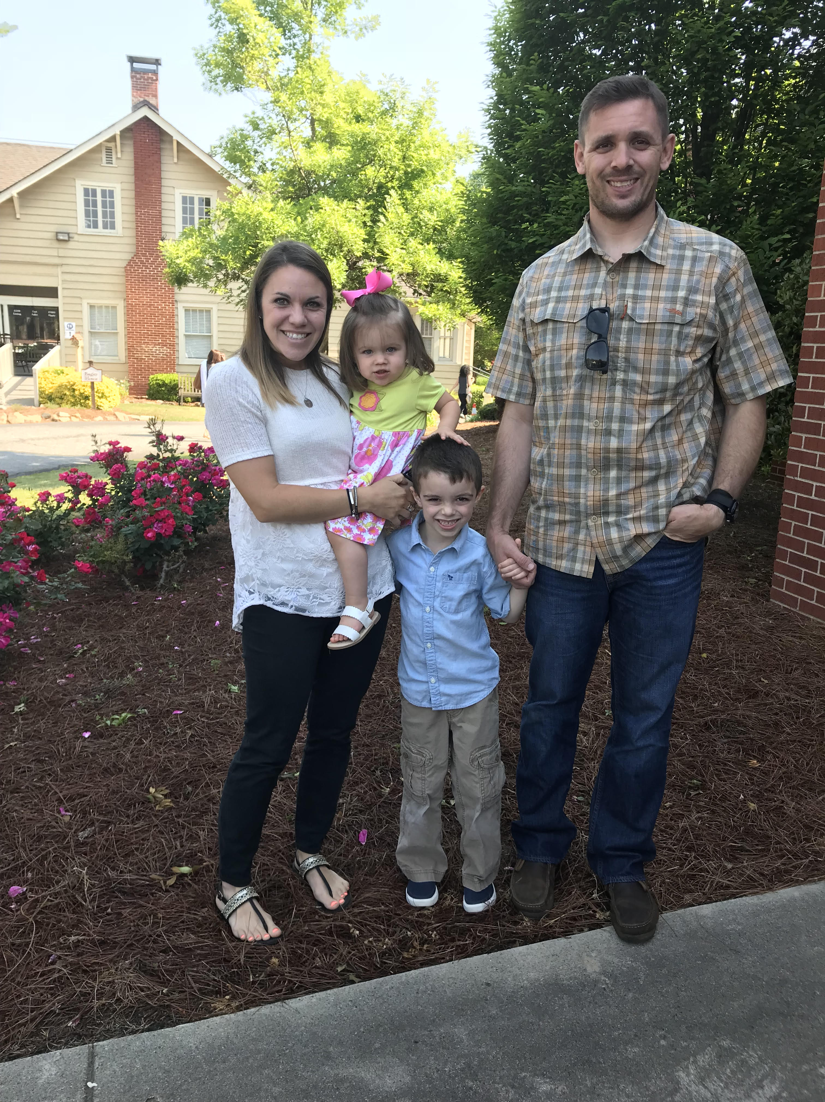

WEBB bridge middle school – head coach

September 2010 – october 2015
- Coached both boys and girls teams
- 2014- Undefeated Girls Season
- 2015- Undefeated Girls Season
ABOUT ME
I am a stay at home mom to my pride and joys, Wilson (5) and Reese (2). Before staying home, I taught sixth and seventh grade at Webb Bridge Middle School. I am a native of Alpharetta and played high school volleyball at Milton High and North Atlanta Volleyball Club.
In my free time, I love playing sports with my children, hiking, running and spending time with my family and friends. I am really looking forward to coaching for Junior Raiders this season. Did I mention that middle schoolers are my favorite?

