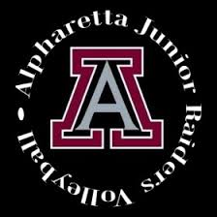
MERCEDES PRESSLEY
JUNIOR RAIDER PROGRAM
Head Coach –Cardinal Team
CONTACT
mercedespressley@icloud.com
404.933.3469
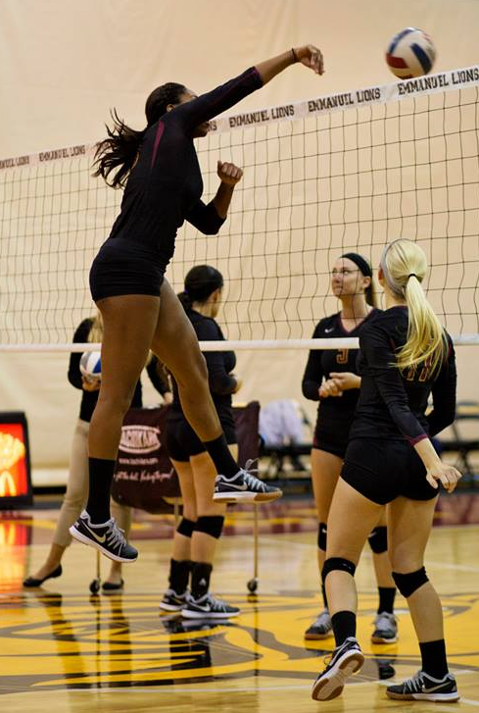
Coaching Goal
My coaching goal is to encourage players to be the best player that they have the potential to be. I want them to fall in love with the game, so that they want to push themselves to do their very best every time.
Coaching Experience
2017 – Present
A5 Volleyball
2017 12-4 Team Head Coach
-4 times Tournament Champions
2017 – 2018
Alpharetta High School
2017 Jr. Raider White Team Head Coach
2016 – Present
Alpharetta Parks and Recreation Department Volleyball Program Director
2014-2015
Viper Volleyball Head Coach
2010-2013
Overkill Volleyball Head Coach
-2017 CPR Certified
Athletic Experience
NCAA Division II –Conference Carolinas at Emmanuel College
NCAA Division II –Gulf South at The University of West Georgia
2011 SRVA Champion
2011 A5 Spotlight Player
Additional Details
-Book/Music lover -Owls and Wolves
-Starbucks Fanatic -Dark Gray

